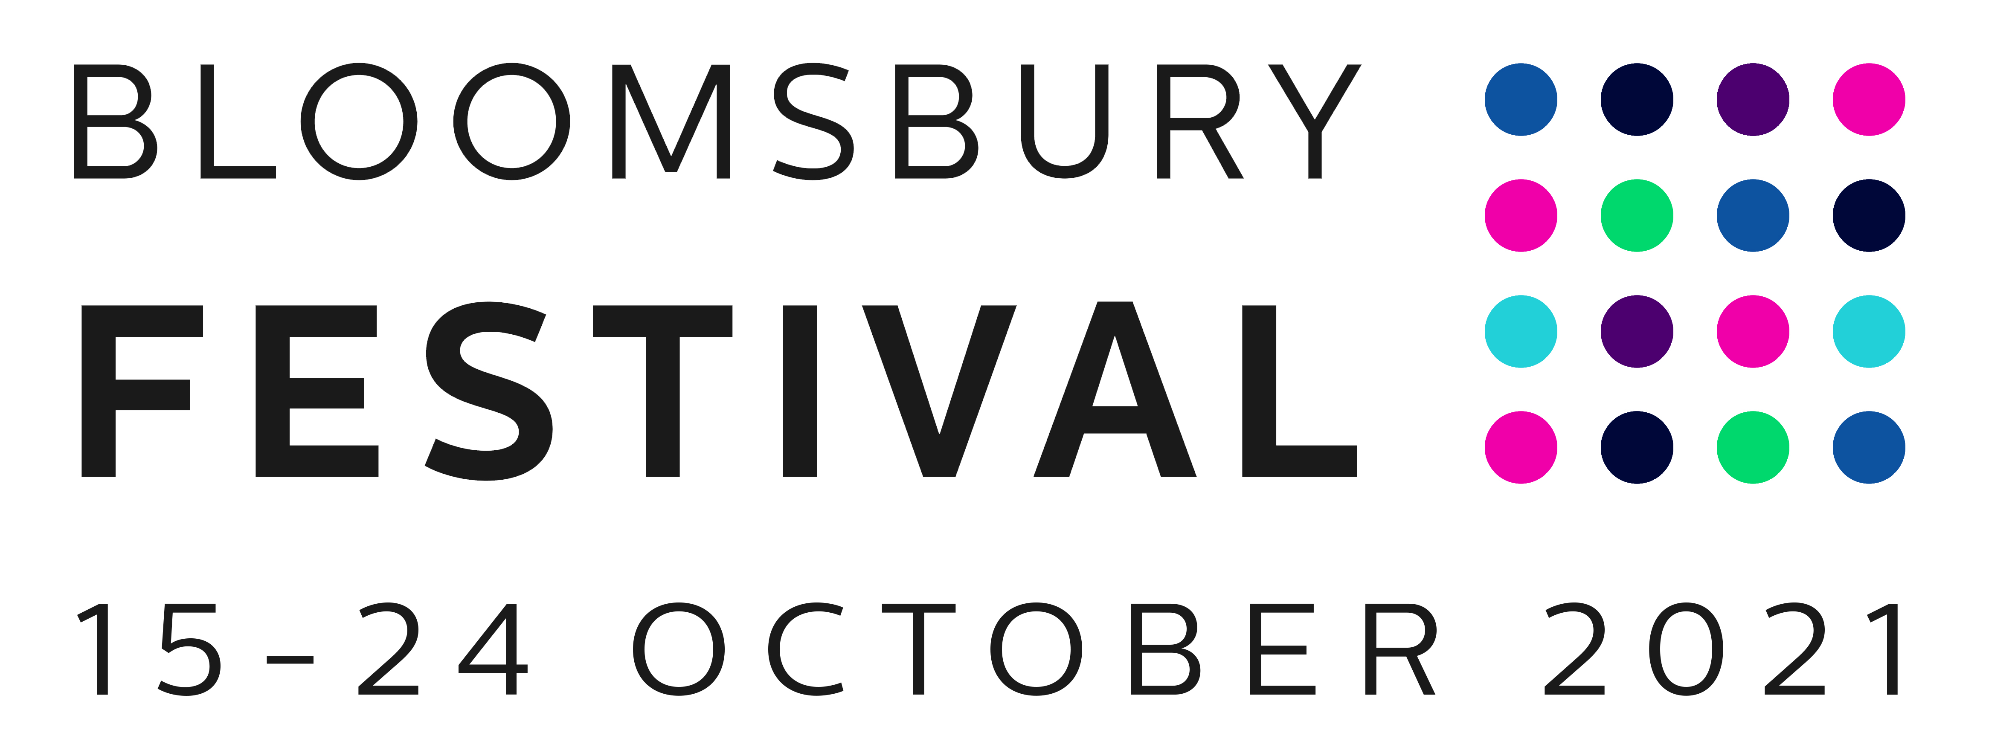

PLEASE RETURN THIS FORM WITH YOUR ENTRY BY 5PM FRIDAY 18 JUNE TO director@bloomsburyfestival.org.uk

Copying in admin@bloomsburyfestival.org.uk

Before you complete the application please check the following details.

CHECKLIST FOR SUBMITTING YOUR ENTRY

- One completed scene with an outline of the full play OR one full script, relevant to the theme ‘Breathe’. Note there is no advantage to writing the full script at this point unless you have already completed a relevant piece.
- If submitting one scene and outline, please add another short example of your script writing or relevant creative writing
- Outlines and Scripts should be submitted electronically to: director@bloomsburyfestival.org.uk by 5pm on

Friday 18 June 2021
- The shortlisted writers will be contacted by email in the first instance by end of June 2021, to be followed by an online announcement
- By entering this production opportunity, you are agreeing to have your name and details used in a press release and online
- Please note you will retain copyright in your own creative work
- The festival may contact writers prior to shortlisting for further discussion about the submitted script before a decision is made.

NOTES

Entries must be completely your own work. It should be a new or recent work, or a script you are currently writing as part of your studies.

Your submitted scene and outline, or full script, must reflect the 2022 Bloomsbury Festival theme Breathe. It should appeal to a young adult audience in its themes and presentation, as well as a wider age theatre going audience.

The rehearsed readings and performances will be given by students working with a professional director and scripts should aim to have a maximum of 10 to 12 characters (note – while the performers for the rehearsed readings and for performers of the Macready Theatre Option will be a diverse group of young adult actors, you do not need to limit all characters to this age group).

The winning writer will be selected by a panel of experts and influential partners at the end of June, including Dr Tim Coker, Artistic Director, Macready Theatre, Rugby and representatives of RADA, the Bloomsbury Festival and freelance professional director/writers.

ENTRY FORM (Please note the panel will not be given the details of the writer at the initial stage of reading)

NAME:

MOBILE NUMBER & EMAIL:

COURSE/THEATRE PROGRAMME TITLE:

PLACE OF STUDY:

CURRENT YEAR OF STUDY:

PLEASE TICK BELOW TO CONFIRM YOUR AVAILABILITY FOR THE PERIOD OF THE FESTIVAL IN LONDON FROM 15-24 OCTOBER 2021:

I confirm that I am available for the period 15-24 October 2021 in London

PLEASE TICK ONE BOX BELOW TO CONFIRM YOUR AVAILABILITY TO TRAVEL TO OCCASSIONAL WORKSHOPS IN RUGBY BETWEEN SEPTEMBER 2021 AND JUNE 2022

(N.B. this is essential for the Rugby Bursary option but not for the Radio Play or Own Staging options and will be scheduled by mutual agreement between the writer and Macready Theatre, Rugby):

I confirm that I will be available to attend workshops in Rugby as outlined above

I am unable to confirm that I will be available to attend workshops in Rugby but

would still like to be considered for the other opportunities outlined above

PLEASE GIVE DETAILS OF PREVIOUS THEATRE OR OTHER WRITING EXPERIENCE YOU THINK IS RELEVANT ALONG WITH A BRIEF NOTE ON YOUR PROPOSED SCRIPT (Max 500 words, continue on a separate sheet if necessary):

BY SIGNING THIS DOCUMENT YOU ARE CONFIRMING THAT YOU ARE AGED 18-25 (OR THAT YOU ARE CURRENTLY ENROLLED ON A FULL-TIME WRITING OR THEATRE-RELATED COURSE OF STUDY). Please note there will be a further radio playwright opportunity in partnership with Bloomsbury Radio for the Bloomsbury Festival 2021 open to writers of all ages.

SIGNED: DATE:

